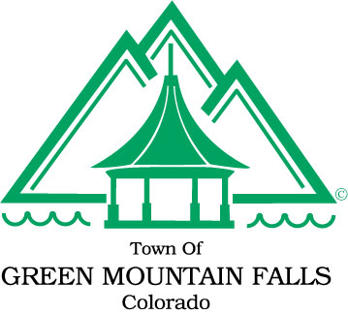
Town of Green Mountain Falls
Special Board of Trustee Meeting Agenda
10615 Green Mountain Falls Road
6:00 p.m.
Tuesday, October 16, 2018

NOTICE OF SPECIAL MEETING
Tuesday October 16, 2018
6:00 p.m.

AGENDA

- CALL TO ORDER / ROLL CALL / PLEDGE OF ALLEGIANCE

- BUSINESS
  - Executive Session Pursuant to C.R.S § 24-6-402(f)(II) for the Purpose of Personnel Matters, specifically to conduct interviews for the Clerk/Treasurer Position.

- ADJOURN

