NEW COMMUNITY DUMPSTER REQUEST FOR QUOTES
The Town of Green Mountain Falls is seeking quotes for the construction of a Dumpster Enclosure in the commercial area. Quotes shall be submitted to Bo Ayad, Town Clerk electronically at clerk@gmfco.us no later than COB on Wednesday, August 16th.
Suggested materials include:
7 posts, 70' of 4"x4"galv 11g
6 posts, 96' of 4"x4"galv 0.25"
frame, 160' of 1.5"x1.5"galv 11g
5 gates, 48' of 1.5"x1.5"galv 0.25"
Pickets, 1664ft 1"x6"x8'
All Materials need to be fire resistant.
*It will be the responsibility of the selected contractor to obtain necessary permits and provide necessary liability insurance.
Job Site:
Green Mountain Falls, CO
Town Business District
Near Ute Pass Ave. & Oak St.
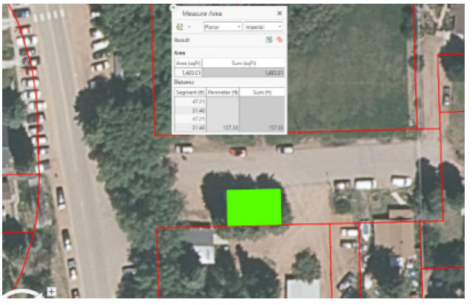

Dumpsters Site Area (45'x12')
