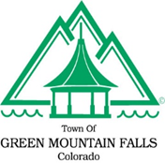
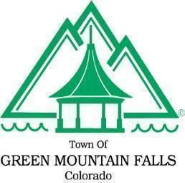
Town of Green Mountain Falls
Parks, Recreation, and Trails Meeting Minutes
10615 Green Mountain Falls Road
Thursday, March 23, 2023 at 7:00 p.m.

STILLING BASIN PUBLIC FORUM MINUTES

Board Members Present  Chair Jesse Stroope  Vice Chair Jay Kita  Member Nancy Dixon  Member Philip McIntire  Member Don Walker  Town Staff Present | Board Members Absent  Secretary  Member Nancy Dixon  Trustees Present  Mayor Todd Dixon

On Thursday, March 23rd, at 7pm in the Town Hall, PRT held a public forum to discuss the park area that has been disturbed by the Stilling Basin project. All PRT members, Mayor Dixon and four GMF residents were present.

Chair Stroope and Vice Chair Kita presented a powerpoint with information on what areas the PRT is able to re-envision by the stilling basin. Two site plan renditions were shown: one with a cutout at the front facing Ute Pass Ave for memorial benches and one with the benches against the retaining wall. Chair Stroope said restrictions are water (no irrigation for vegetation) and funding. A resident suggested a fundraiser to help with the costs. It was also suggested that the new area mirror/reflect the look of Gazebo lake.

Where the social trail is steep, tiers were suggested to help with making the trail easier to walk. A crosswalk marked from the social trail across Ute Pass Ave to Gazebo lake would be helpful to safely guide pedestrians.

Combining the two options was preferred. Having the benches angled along the retaining wall was suggested so the view of Gazebo lake was optimized. This could possibly reroute the social trail. Spurs from the trail would be needed for access to the location of the benches.

A new wayfinding sign to direct walkers to the trail from Hotel St, some landscaping and a bench was discussed for the upslope of the park. The boulders that are there could be relocated.

For vegetation, Chair Stroope had a list of native, xeriscape grasses/plants since there is no irrigation at this park. Sowing the area with native grass/wildflower seeds was recommended.

There is a historic hotel marker and a memorial marker that need to be replaced at the park also.

The PRT will work on an activity that has the community help name this park.

